* 1. Communications Management Plan
     1. Introduction

The Communications Management Plan for Rams E-Caf outlines the strategies and approaches to effectively manage and facilitate communication within the project. This plan recognizes the importance of clear and consistent communication in ensuring project success, stakeholder engagement, and timely decision-making. By establishing guidelines and processes for communication, the Rams E-Caf project team can effectively exchange information, manage expectations, and foster collaboration among team members and stakeholders.

The Communications Management Plan for Rams E-Caf encompasses various aspects, including the identification of key stakeholders, communication objectives, channels, and frequency of communication. It defines the roles and responsibilities of communication focal points within the project team and establishes a clear escalation path for addressing any communication issues or conflicts that may arise. Additionally, the plan outlines methods for documenting and archiving project communications, ensuring transparency and accountability.

By implementing the Communications Management Plan, Rams E-Caf can facilitate efficient and effective communication, enhance stakeholder relationships, mitigate risks, and ensure that project information is disseminated to the right people at the right time. This plan serves as a roadmap for the project team to navigate the complexities of communication and foster a collaborative and informed project environment.

* + 1. Communications Management Approach

The communications management approach for Rams E-Caf is designed to ensure effective and efficient communication throughout the project. The approach involves clear and concise communication strategies, channels, and processes that enable timely and accurate exchange of information among stakeholders. By implementing this approach, Rams E-Caf aims to enhance collaboration, maintain transparency, and facilitate informed decision-making.

The communications management approach includes identifying key stakeholders and their communication needs, establishing clear communication objectives, and determining the most appropriate channels for communication. It also outlines the frequency and timing of communication activities, ensuring that information is shared in a timely manner. Additionally, the approach emphasizes the importance of two-way communication, encouraging feedback and active participation from stakeholders.

To support the communications management approach, Rams E-Caf will utilize various communication tools and technologies, such as project management software, email, meetings, and progress reports. Regular communication checkpoints and updates will be established to keep stakeholders informed about project progress, milestones, and any changes or issues that may arise.

* + 1. Communications Management Constraints

Communications management constraints for Rams E-Caf refer to the limitations or challenges that may impact the communication processes and activities within the project. These constraints can arise from various factors and need to be identified and addressed to ensure effective communication. Some of the common communications management constraints for Rams E-Caf may include:

1. Time Constraints: Projects often operate under tight timelines, which can restrict the availability of stakeholders and limit the time allocated for communication activities. Time constraints may lead to rushed or inadequate communication, impacting the clarity and effectiveness of the messages conveyed.
2. Resource Constraints: Limited resources, such as budget and technology infrastructure, can pose challenges in implementing robust communication strategies. Insufficient resources may limit the use of advanced communication tools or hinder the establishment of dedicated communication channels, affecting the efficiency and reach of communication efforts.
3. Geographical and Cultural Constraints: Rams E-Caf may operate in a distributed environment with team members or stakeholders located in different geographic regions or with diverse cultural backgrounds. These differences can create communication barriers, including language barriers, time zone differences, and varying communication preferences, which need to be addressed for effective collaboration.
4. Stakeholder Availability and Engagement: The availability and engagement of stakeholders can impact the success of communication efforts. Stakeholders with busy schedules or competing priorities may not be readily accessible, making it challenging to obtain timely feedback or approvals. Lack of stakeholder engagement can result in miscommunication, delays, and hindered decision-making processes.
5. Information Overload: In complex projects like Rams E-Caf, there can be a significant amount of information to be communicated. The risk of information overload arises when stakeholders are overwhelmed with excessive or irrelevant information, leading to confusion and reduced attention to critical project updates.
6. Legal and Regulatory Constraints: Depending on the industry and nature of the project, there may be legal or regulatory requirements that dictate how information is communicated or shared. Compliance with these constraints may impact the communication approach, requiring additional measures to ensure confidentiality, privacy, or data protection.

Understanding and addressing these communication management constraints is essential to develop strategies that mitigate their impact. By proactively identifying and planning for these constraints, Rams E-Caf can overcome communication challenges, enhance stakeholder engagement, and improve project outcomes.

* + 1. Stakeholder Communication Requirements

The Stakeholder Communication Requirements are a vital component of the Rams E-Caf project as they outline the specific communication needs of all stakeholders involved in the project. Effective communication is essential for ensuring that the project is completed on time, within budget, and to the satisfaction of all stakeholders. By identifying and addressing the communication requirements of stakeholders, the project team can proactively manage expectations, build trust, and foster collaboration.

Stakeholder Communication Requirements for Rams E-Caf may include:

1. Project Sponsor: The project sponsor may require regular updates on project progress, financial status, and key milestones. They may also expect communication regarding any significant risks or changes that could impact on the project's success.
2. Project Manager: The project manager may require open and transparent communication with all stakeholders, ensuring they are informed about project objectives, scope, and timelines. The project manager may also need to communicate any issues or risks that require stakeholder attention and involvement.
3. Project Team: The project team members may require clear communication regarding their roles, responsibilities, and project deliverables. They may also need regular updates on project status, task assignments, and any changes to project requirements or timelines.
4. Clients: The clients may require frequent and effective communication to ensure their needs and expectations are understood and met. This may include updates on project progress, demonstrations of project deliverables, and opportunities for client feedback and input.
5. End Users: The end users of the Rams E-Caf system may require communication regarding system functionalities, training opportunities, and support resources. They may also need clear instructions on how to use the system and access relevant information or support.
6. External Suppliers: External suppliers may require timely and accurate communication regarding project requirements, delivery schedules, and any changes or issues that may impact their involvement in the project.

It is important to identify and analyze the specific communication needs of each stakeholder group to ensure effective communication channels and methods are in place throughout the project. Regular feedback loops, status meetings, progress reports, and clear documentation can help meet these communication requirements and ensure stakeholder engagement and satisfaction.

* + 1. Roles

|  |  |
| --- | --- |
| **Roles** | **Responsibilities** |
| Project Sponsor | A high-level executive who provides financial resources and strategic direction for the project. |
| Program Manager | A person responsible for overseeing the Rams E-Caf and ensuring that it aligns with the organization's overall goals and objectives. The program manager might oversee multiple related projects within the organization. |
| Key Stakeholders | Individuals or groups who have a vested interest in the Rams E-Caf, such as team members, managers, and technicians who rely on the system for their daily operations. |
| Project Manager | The person responsible for planning, executing, and closing the Rams E-Caf. The project manager leads the project team and ensures that the system is completed on time, within budget, and to the required quality standards. |
| Development Team | A person responsible for the technical aspects of the Rams E-Caf, such as the system architecture, database design, and software development. The team ensures that the system meets the required technical specifications and standards, and that it is scalable, secure, and reliable. |

*Table 6.7—1: Communication Management Roles and Responsibilities*

* + 1. Project Team Directory

The following table presents contact information for all persons identified in this communications management plan. The email addresses and phone numbers in this table will be used to communicate with these people.

|  |  |  |  |  |
| --- | --- | --- | --- | --- |
| **Name** | **Position** | **Internal, External** | **Project Role** | **Contact Information** |
| Ms. Bernadette Sison | Staff at APC Center | Internal | Project Sponsor | [berniel@apc.edu.ph](mailto:berniel@apc.edu.ph) |
| Users | Asia Pacific College Community | Internal | Internal User of the system | apc.edu.ph |
| Technicians | APC IT Resource Office | External | External user of the system | [itro@apc.edu.ph](mailto:itro@apc.edu.ph) |
| Managers | APC Center | External | External user of the system | [APCCenter@apc.edu.ph](mailto:APCCenter@apc.edu.ph) |
| Corneliani Melo | Student | Internal | Project Manager | [cgmelo@student.apc.edu.ph](mailto:roselyn.angeles@telusinternational.com) |
| Jamir Sia | Student | Internal | Developer | [jazsia@student.apc.edu.ph](mailto:jazsia@student.apc.edu.ph) |
| Nathan Sinaguinan | Student | Internal | Project Team Leader | [nbsinaguinan@student.apc.edu.ph](mailto:nbsinaguinan@student.apc.edu.ph) |
| Isiah Tutor | Student | Internal | Documentation | [imtutor@student.apc.edu.ph](mailto:imtutor@student.apc.edu.ph) |
| Joshua Cudal | Student | Internal | Documentation | [jpcudal@student.apc.edu.ph](mailto:jpcudal@student.apc.edu.ph) |

*Table 6.7—2: Project Team Directory*

* + 1. Communication Methods and Technologies

The communications management plan for Rams E-Caf encompasses various methods and technologies to ensure effective and efficient communication among project stakeholders. By leveraging email, meetings, project management software, collaboration platforms, document management systems, video conferencing tools, and project dashboards, Rams E-Caf aims to promote collaboration, address stakeholder needs, and maintain a shared understanding of project progress. With clear guidelines and protocols in place, the plan establishes streamlined communication processes and facilitates transparent information exchange. The goal is to foster collaboration, mitigate risks, and achieve successful project outcomes through effective stakeholder engagement and communication.

Communication Methods and Technologies of Rams E-Caf can include:

1. Email: Email is a widely used communication method for sending written messages, project updates, and documentation to stakeholders involved in Rams E-Caf. It allows for asynchronous communication and can be used for formal or informal communications.
2. Meetings: Face-to-face or virtual meetings provide an opportunity for stakeholders to come together, discuss project progress, address concerns, and make decisions. Meetings can be scheduled at regular intervals or on an ad-hoc basis as needed.
3. Project Management Software: The use of project management software, such as Jira, Trello, or Microsoft Project, can facilitate communication and collaboration among project team members. These tools allow for task assignment, progress tracking, document sharing, and discussion forums.
4. Collaboration Platforms: Collaboration platforms like Slack, Microsoft Teams, or Google Workspace provide real-time communication channels, file sharing, and integration with other project management tools. They enable teams to collaborate, share updates, and engage in discussions.
5. Document Management Systems: Document management systems, such as SharePoint or Google Drive, allow for central storage, version control, and sharing of project documents, plans, and reports. They ensure that stakeholders have access to the latest information and can collaborate on document editing.
6. Video Conferencing: Video conferencing tools like Zoom, Microsoft Teams, or Google Meet enable remote stakeholders to participate in virtual meetings, discussions, and presentations. They facilitate face-to-face communication and can include features like screen sharing and chat for enhanced collaboration.
7. Project Dashboards: Project dashboards provide a visual representation of project status, metrics, and progress. They can be accessed by stakeholders to quickly grasp the project's health and key updates without detailed communication.

The choice of communication methods and technologies will depend on the preferences and needs of the stakeholders, project requirements, and the availability of resources. It is essential to establish clear guidelines and protocols for communication to ensure consistent and effective information exchange throughout the Rams E-Caf project.

* + 1. Communications Matrix

|  |  |  |  |  |  |  |
| --- | --- | --- | --- | --- | --- | --- |
| **Channel** | **From** | **To** | **Type** | **Frequency** | **Format Used** | **Delivery media** |
| Project Planning | Project Manager | Stakeholders | Meeting | Once Before  the start of the project | Formal | MS Teams |
| Release planning | Project manager, Project team | Stakeholders | Meeting | Once before start of the project Updated when necessary | Formal | Email, MS Teams |
| Sprint Planning | Project manager | Project team | Meeting | Once every week | Informal | MS Teams |
| Management processes | Project manager, project team | Stakeholders | Artifact | Once Before start of the project Updated when necessary | Written Document | MS Teams, MS Word |
| Product backlog | Project manager | Project team | Artifact | Once every week | Written Document | MS Word |
| Project update | Project Manager | Project team | Meeting | Once every week | Informal | MS Teams |

*Table 6.7—3: Communication Matrix*

* + 1. Communication Flowchart

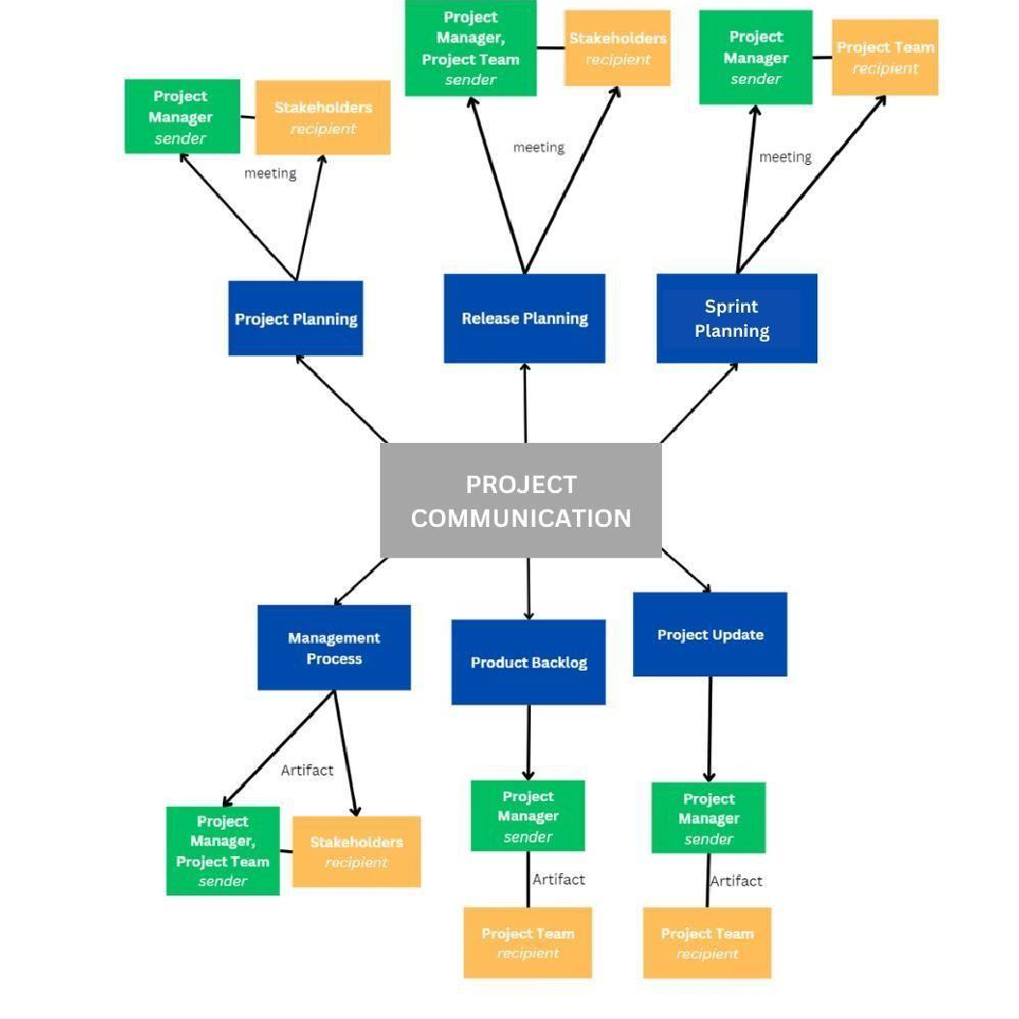

*Figure 6.7—1: Communication Flowchart*

* + 1. Guidelines for Meetings

Meetings are a key component of effective communication in any project. The Rams E-Caf project is no exception. In order to ensure that meetings are productive, efficient, and effective, it is important to establish clear guidelines for meetings. These guidelines should include information on the purpose of meetings, the roles and responsibilities of attendees, and the procedures that will be followed during meetings.

Guidelines for Meetings of Rams E-Caf:

1. Purpose and Agenda: Clearly define the purpose of the meeting and establish a well-defined agenda beforehand. This ensures that the meeting stays focused and addresses the necessary topics.
2. Attendees: Invite only the relevant stakeholders whose presence is required for the meeting. Keep the attendee list concise to maximize efficiency and minimize distractions.
3. Schedule and Timing: Set a specific date, time, and duration for the meeting. Stick to the schedule to respect everyone's time and avoid unnecessary delays.
4. Preparation: Circulate meeting materials, such as agendas, presentations, or documents, in advance. This allows participants to review the materials and come prepared with any questions or input.
5. Facilitation: Appoint a skilled meeting facilitator who can guide the discussion, manage time effectively, and ensure everyone has an opportunity to contribute. The facilitator should encourage active participation and maintain a respectful and collaborative atmosphere.
6. Participation and Engagement: Encourage open and constructive dialogue among attendees. Give everyone a chance to share their perspectives, ask questions, and provide input. Foster an inclusive environment where all ideas are valued.
7. Action Items and Follow-up: Document action items, decisions, and key discussions during the meeting. Assign responsibilities and deadlines for action items and ensure that follow-up communication is sent to all relevant stakeholders to track progress.
8. Time Management: Stay focused on the agenda and allocate sufficient time for each topic. Avoid getting sidetracked by unrelated discussions or going off-topic. Respect the allocated time for the meeting and conclude on time.
9. Documentation: Maintain accurate meeting minutes or summaries that capture key points, decisions, and action items. Share these minutes with attendees and other stakeholders who may require the information.
10. Evaluation and Continuous Improvement: After each meeting, assess its effectiveness and gather feedback from participants. Identify areas for improvement and make adjustments to future meetings to enhance communication and collaboration.

By following these guidelines, Rams E-Caf can conduct productive and efficient meetings that facilitate effective communication, collaboration, and decision-making among project stakeholders.

* + 1. Communication Standards

The best communication standards for the Rams E-Caf project may include the following:

* + - * **Standardized Templates:** Developing and using standard templates for project communications, such as status reports, meeting agendas, and minutes, can ensure consistency and clarity in the information being shared.
      * **File Naming Convention:** Developing a standard file naming convention for documents and files shared on the project can help ensure easy access and organization of information.
      * **Web Portal/Network Tool:** Utilizing a standard platform, such as SharePoint or project management software, for project communication can improve access to information and collaboration among team members and stakeholders.
      * **Video conferencing:** Use of Video conferencing tools like Google Meets, Zoom, Skype, etc. can be very useful for team members and stakeholders who are located at different geographic locations.
      * **Communication protocols:** Having a standard communication protocol in place for sensitive or confidential information, such as who is authorized to share it and how it should be shared, can ensure the protection of sensitive data.
    1. Communication Escalation Process

The ideal and best communication escalation process for the Rams E-Caf project would involve the following steps:

Communication Standards of Rams E-Caf:

1. Clarity and Conciseness: Communications within Rams E-Caf should be clear, concise, and easily understood by all stakeholders. Avoid using technical jargon or complex language that may hinder comprehension.
2. Professional Tone: Maintain a professional and respectful tone in all communications. Use appropriate language and avoid any form of discrimination, bias, or offensive remarks.
3. Timeliness: Respond to communications promptly and adhere to agreed-upon timelines for delivering information or updates. Avoid unnecessary delays and ensure that critical messages are communicated in a timely manner.
4. Consistency: Maintain consistency in the style, format, and branding of all communications. This includes emails, reports, presentations, and any other communication materials related to Rams E-Caf.
5. Use of Technology: Leverage appropriate communication technologies and platforms to facilitate efficient and effective information exchange. This may include email, instant messaging, project management tools, video conferencing, or other collaboration software.
6. Confidentiality and Data Privacy: Respect and maintain the confidentiality and privacy of sensitive information shared within Rams E-Caf. Adhere to applicable data protection regulations and policies.
7. Accessibility: Ensure that communications are accessible to all stakeholders, considering diverse needs such as language preferences, disabilities, or cultural differences. Provide necessary accommodation or translations when required.
8. Feedback and Collaboration: Encourage open feedback and collaborative discussions within Rams E-Caf. Foster an environment where all stakeholders feel comfortable expressing their opinions and ideas.
9. Documentation: Maintain accurate and comprehensive documentation of important communications, decisions, and agreements. This helps ensure transparency, accountability, and provides a reference for future discussions.
10. Stakeholder Engagement: Actively engage with stakeholders and promote two-way communication. Seek input, address concerns, and involve stakeholders in decision-making processes whenever appropriate.

By adhering to these communication standards, Rams E-Caf can establish a framework for effective and efficient communication that promotes understanding, collaboration, and successful project outcomes.

* + 1. Glossary of Communication Terminology

|  |  |
| --- | --- |
| **Term** | **Definition** |
| **Communication Plan** | A document outlining the communication strategy and protocols for the project team and stakeholders. |
| **Stakeholder** | An individual or organization that has an interest or concern in the project. |
| **Communication Method** | The means by which information is conveyed, such as meetings, email, telephone, or web portal. |
| **Communication Frequency** | The regularity with which project communications are distributed. |
| **Communication Objective** | The desired outcome or goal of a particular communication. |
| **Communication Flowchart** | A diagram showing the flow of information within a project. |
| **Escalation Process** | A procedure for resolving communication-based conflicts or issues. |
| **Communication Matrix** | A table outlining the communication requirements for a project. |
| **Communication Standards** | Standard templates, formats, or documents used for communicating within a project. |
| **Communication Constraints** | Factors that may limit or affect the effectiveness of project communications. |
| **Communication Guidelines** | Protocols for conducting meetings, teleconferences, and other forms of communication. |
| **Communication Technology** | Tools and platforms used for communication, such as SharePoint, message boards, and video teleconferencing. |
| **Communication Escalation Process** | A process for escalating communication-based issues or conflicts that cannot be resolved within the project team. |
| **Communication Approaches** | Different strategies and solutions are implemented to address communication constraints, ensuring that all stakeholders are kept informed and that the project's communication objectives are met. |

*Table 6.7—4: Glossary of Communication Management Terminologies*